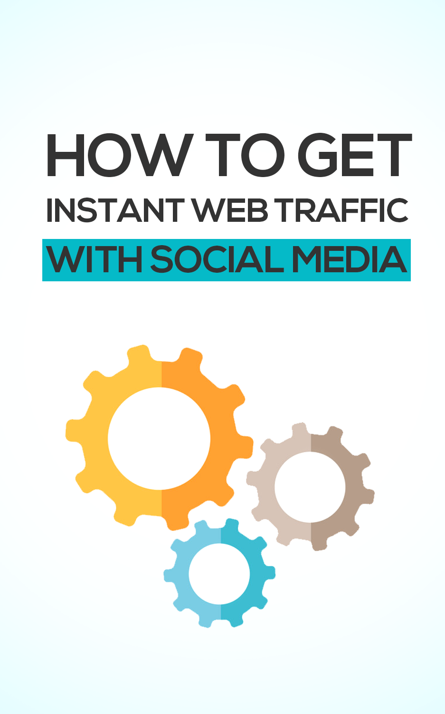

TOP RECOMMENDED GUIDE:

**Traffic Machine**

5 Powerful Strategies To Increase Website Traffic

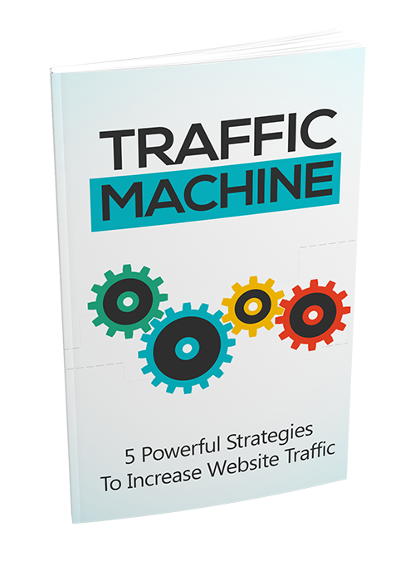

Get Your Copy Today!



**>> Click Here To Get Your Copy <<**

Everyone makes using social media to drive traffic sound so easy. All you have to do is post a few times on Facebook, Twitter or LinkedIn, and the traffic will start pouring in.

The reality, like with anything else is that you need to spend enough time learning how to do it properly.

If you didn’t already know, social media traffic is one of the largest referrers, when it comes to driving web traffic, at your disposal.

In fact, according to Shareaholic, social media traffic makes up 31 percent of overall traffic, with Facebook alone accounting for 17.41 percent of the traffic.

With high-quality visitors from social media, you can build a business. With social media traffic continuing to grow, it's never too late to get started.

To be successful in driving more traffic with social media, you'll need a strategy.

A good social media strategy will serve your company in many ways:

* Increased traffic
* Relationship building
* Better customer retention/satisfaction
* Better customer service

The one thing that you have to remember is that consistency is key when it comes to your social media strategy. If you only execute your plan for one day, you'll see no results.

If you just do it for a month, you'll see some results. If you execute it for a year, you will see a significant increase in traffic. If you are looking for a magic bullet that will allow you to get the traffic without doing the work, you’re not going to find it.

You have to work at it if you want to build long-term sustainable traffic for your business. If you fully commit to your strategy, you’ll reap the rewards of your hard work.

## Understanding Your Reader’s Minds

When it comes to being successful with your social media marketing efforts, you have to know which social networks your target audience is using.

If your blog is targeted towards the elderly, the last place you want to try to build a following on is Instagram. Even if you do everything right, you will never get any significant traffic from your efforts.

The foundation of your social media strategy is to first and foremost to learn who your target audience is and why they use social media. To accomplish this, you have to utilize demographics.

***Determining Demographics***

Your demographics will tell you the who, and include:

* Location
* Gender
* Age
* Income
* Education level
* Ethnicity
* Marital status
* Religion
* Number of children

Determining your demographics will depend on whether you have a website and traffic already.

If you don't have a site yet, you will need to find a website that is similar to your business and use it for your analysis.

In determining demographics, there are a few options. You can use Alexa to help you with figuring out your audience. All you need to do is enter your site or competitors into the search bar, and it will provide you with the information you need.

You can also use Google Adwords Display Planner. With this tool, you just need to enter a keyword that describes your niche into the search bar.

When you hit the submit button, you'll get a screen that displays useful age and gender information at the top.

The final way you can gather demographic information is with Google Analytics. The data is collected from your site and reveals key metrics for both age and gender.

This data is the best source of information for you because it represents your actual audience.

## Choose the Most Effective Platform

After you've determined your demographics, you'll want to pick one or two social media platforms to focus all your marketing efforts on.

By investing the extra time on just a few channels, you’ll get better and quicker results, than if you were to try and invest in all the various social media platforms.

You will need to find a platform where your audience hangs out. Start narrowing down your choices based on the age of your audience.

Vine and Tumblr tend to be better options for a younger demographic, while LinkedIn and Facebook are better for an older demographic.

While Facebook is starting to lose popularity among the younger users, 70 percent of adults are still active on the site.

## Create Content that Adds Value

Now that you have a better understanding of your target audience and have chosen a couple of social media channels to focus on, it’s time to begin developing content that delivers value to them.

It is important to remember that the more value you can bring them the faster your presence will grow online.

The second part of the equation is consistency.

Unlike search engine traffic, that can continue to grow even if you don't publish new content; you have to remain consistent on social media to improve your traffic.

To do this, you need to create as much content as possible that your target audience will love. Your content can include any of the following, depending on the channels you've chosen.

* Blog posts
* Pictures
* Infographics
* Videos
* Quotes
* Jokes
* Quick tips

The right kind of content will depend entirely on the networks you’re focusing on. It is also important to understand with social media is that to keep your audience engaged, you can't just share your own content.

When you are first starting out, you want to err on the side of being non-promotional and share content that others have created.

## Get Followers

Sharing your content without having any followers is a waste of your time. Without people seeing, reading, and re-sharing the content you share you will never have the chance to build relationships and trust, and you will never see any significant traffic for your efforts.

One of the easiest, and most effective ways to gain followers, at first, is to follow as many of your target audience members as possible.

A generous percentage of these people will follow you back. As you share content, the number of followers will begin to grow and so will your traffic.

## Determining the Optimal Frequency of Posts

As you begin to share more content, you’ll start to notice that you might get a few clicks every time you post something new. You may start to think that if you shared twice as much, you’d get twice as much traffic.

To some extent, that thinking is correct. However, you have to be careful, so that you don’t start being seen as a spammer.

You'll want to test the frequency of your postings to optimize your strategy for your business. Depending on your audience, you may need to share more or less. Here is a list of ideal frequencies to post on your social media platforms.

* Pinterest – five posts a day
* Twitter – three posts a day
* Google+ - three posts a day
* Facebook – two posts a day

## Track Your Results

Your social media strategy is almost complete. You just need to do this one last step. While this is the easiest of all the steps, if not done, it can make or break your success.

If you don’t track your results, you won’t be able to see what is working and what isn’t. Knowing this information can help you improve your strategy to see even better results.

Using a spreadsheet, record all your shares. This allows you to see which posts are attracting the most clicks and engagements, and which ones aren’t.

Knowing this information will help you learn how to write descriptions that will get the most attention.

The easiest way to get these stats is by signing up at Buffer. The site tracks your clicks, shares, and impressions and delivers them in an easy to understand format.

Continue to look at these numbers to see if they are slowly going up if they aren't then you'll have to rethink your strategy.

To ensure that you are effectively pushing traffic to your site, you’ll also want to use Google Analytics. Start by looking at the overall traffic. This will show you how much traffic you are getting from each network.

If the data presented isn't showing your traffic increases over time, you'll need to figure out why. Additionally, by adding the secondary dimension of "referral path," the information will show you where your traffic is coming from.

Some of the networks will allow you to see precisely what post sent the traffic to your website. Unfortunately, there are some, most notably Twitter, that will only provide you with a jumbled-up referral list that isn’t very useful.

As you continue to implement your strategy and track the results, you'll want to start studying the specific posts that gave you the most traffic.

Focus on those posts that you shared that weren't yours. Start building relationships with these individuals to increase your chances of getting significant recurring traffic.

## Conclusion

This may seem like a ton of work, and it is. But if you want to get serious about driving traffic to your site, your social media strategy is crucial.

A solid social media strategy isn’t for the light of heart. It will take time for you to build your first plan and execute it successfully, but your efforts will be well worth it when you start seeing the results of your efforts in increased traffic.

TOP RECOMMENDED GUIDE:

**Traffic Machine**

5 Powerful Strategies To Increase Website Traffic



Get Your Copy Today!



**>> Click Here To Get Your Copy <<**